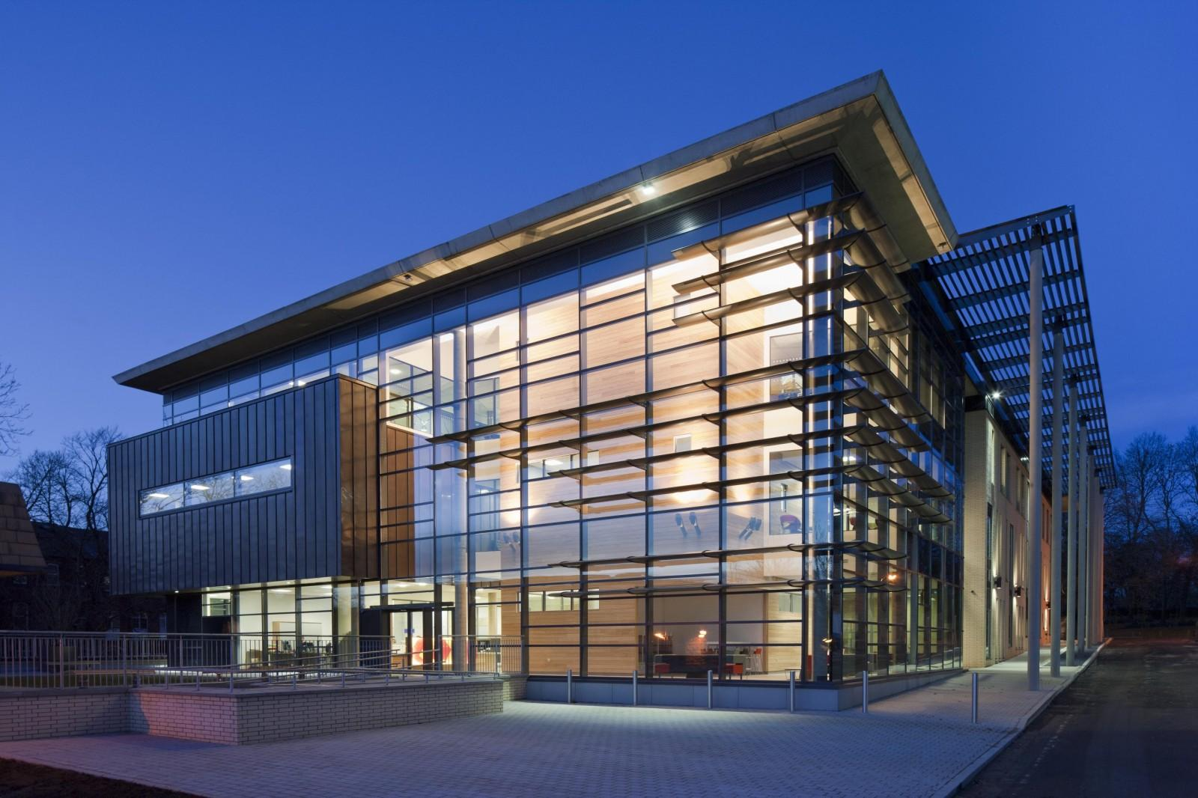

Business in the 21st Century: Business as Usual?

Inclues keynote presentation by Professor Sofia Ranchordás on ‘The New Economy: the shift from B2C to P2P, virtual competition, and how technology is reshaping the public and private sector.

About the Centre for Business Law and Practice

Established in 1996, the Centre for Business Law and Practice (CBLP) is an internationally recognised, leading business law research centre. The Centre’s particular, unique feature is the breadth and diversity of the research expertise of its members. The Centre aims to address matters of contemporary concern in business law and regulation using pluralistic perspectives that mix disciplinary and inter-disciplinary approaches. It strives for high quality research outputs that have a broader societal impact.

Programme

08:30 – 09:00 Registration
09:00-09:30 ???
09:30 - 10.45 Panel I: Innovation, Art and the Law (Chair: Ananya Banerjee)
10:45 – 11:00 Coffee Break
11:00 – 12:00 Keynote speaker: Professor Sofia Ranchordás
12:00 – 13:00 Lunch
13:00 – 14:15 Panel II: Competition Law in the 21st Century (Chair: Magali Eben)
14:15 – 14:30 Coffee Break
14:30 – 15:45 Panel III: Cross-Border Legal Issues (Chair: Omar Mashjari)
15:45 – 16:00 Coffee Break
16:00 – 17:45 Panel IV: Company and Insolvency Law (Chair: Oriana Casasola)
17:45 Refreshments and Networking

Keynote Speaker: Prof. Sofia Ranchordás

Sofia Ranchordas holds an LLB and LLM (summa cum laude) from the Universidade Catolica Portuguesa (Portugal), an LLM in Law Economics (cum laude) from Utrecht University, and a PhD (cum laude) from Tilburg University and University of Antwerp. After her PhD she was a Visiting Scholar at George Washington University Law School (2014) and a Resident Fellow at the Information Society Project at Yale Law School (2015-2016). She has been the recipient of both national and international grants and awards (e.g., Niels Stensen Fellowship, Knight Foundation, NWO Smart Governance). She held previous teaching positions at Tilburg University and Leiden University. She is a frequent speaker at international conferences.

She is a member of the editorial board of the peer-reviewed journal Law & Method and the co-founder of the European Law & Tech Network.

Sofia will present on "The New Economy", discussing her research into the platform economy, the shift from B2C to P2P in different sectors, virtual competition, and how technology is reshaping the public and private sector.

Panel I
Innovation, Art and the Law
Chair: Ananya Banerjee

- ‘The Internet, Search Costs and the Erosion of Trademark Value’
Adam Buick (University of Leeds)

- ‘Mobility-as-a-Service and Consumer Protection: the Future Proof Business as Usual?’
Josje de Vogel (Erasmus University Rotterdam)

- ‘(Cross-Border) Impact of Tax on Commercial Arts Industry’
Evelyse Carvalho Ribas (University of Leeds)

Panel II

Competition Law in the 21st Century
Chair: Magali Eben

- ‘The Proportionality of the Refusal to Supply Doctrine under Article 102TFEU’
Omar Mashjari (University of Leeds)

- ‘Data Governance on Online Platforms and Application of Competition Policy’
Ritam Arora (University of Maastricht / UPES)

- ‘The ECN Plus Project: Updating the ECN to Face the Challenges of the Online World)’
Gabriele Carovano (King’s College London / OECD)

Panel III
Cross-Border Legal Issues
Chair: Omar Mashjari

- ‘Corporate Law and Corporate Social Responsibility in Developing Countries’
Ibukun Iyiola-Omisore (University of Leeds)

- ‘The Efficiency of Converging Market Accessibility Regulations: What an Emerging Market Economy Can Learn from the ‘Best Practice Models’ US and UK’
Saad Almohammed Alrayes (Queens’ University Belfast)

- ‘The Intelelctual Property Deadlock: Examining Precipitants of Departures and Key Turning Points in Chile’s Negotiations on Biologics in the Trans-Pacific Partnership’
Fifa Rahmen (University of Leeds)

Panel IV
Company and Insolvency Law
Chair: Oriana Casasola

- ‘Differentiated Protection for (Different Factions of) Unsecured Creditors: a Solution to Reduce Vulnerability’
Dennis Cardinaels (University of Leeds)
- ‘Devising an Efficient and Well-functioning Corporate Rescue System om English Insolvency Law’
Jadesola Faseluka (University of Leeds)
- ‘The Modernisation of Belgian Company Law: Reflections on the New Director Liability Regime’
Elke Hellinx (Katholieke Universiteit Leuven)
- ‘Foreign Takeover Rules in China and the Netherlands: Implications for a Global Level Playing Field’
Du Du (Erasmus University Rotterdam)

Thank you for attending the Conference!



Organising Committee: Oriana Casasola and Magali Eben.

A special thanks to: Prof. Pinar Akman, Dr. Suren Gomtsyan, Dr. Konstantinos Stylianou.

